​**Green Society Public School**

**D-04**

**Ratnanagar-7, Sauraha, Chitwan**

**Second Terminal Examination-2082**

**Class: Two Time: - 2 hrs. F.M.: 50**

**Sub: Maths**

|  |
| --- |
| **Name: Roll No.: Sec.:** |
| **­­­­­­­­­­­­ ________________ ______________ OBT.MARKS:**  **INVIGILATOR EXAMINER** |

**Group ‘A’**

​**1] Tick (✓) the correct answer. [10×1=10]**

a) Which is an even number?

i) 5 ii) 8 iii) 9

b) Which is an odd number?

i) 10 ii) 14 iii) 7

c) The addition of 21 and 34 is

i) 55 ii) 56 iii) 54

d) The subtraction of 45 and 22 is

i) 23 ii) 33 iii) 25

e) How many mililitre { ml} are there in 1 litre{L}?

i) 10000 ii) 1000 iii) 2000

f) 1 cm is equal to:

i) 10 mm ii) 1 mm iii) 100 mm

g) How many days a week has?

i) 7 days ii) 5 days iii) 6 days

h) Which has greater area?

i) eraser ii) pencil iii) book

i) [ ?] – 9 =2

i)11 ii) 12 iii) 10

j) [ ? ] + 33= 55

i) 22 ii) 21 iii) 20

**​Group ‘B’ [12×2=24]**

​**2) Colour the given fraction in each of the following.**

3

2

|  |  |  |
| --- | --- | --- |
|  |  |  |
|  |  |  |

4

6

**3)Add the following.**

3 5 3

2

8 3 6

2

3 3 6

2

1 5 2

2

​**4) Add horizontally.**

452 + 434 = 423 + 465 =

​**5) Subtract the following horizontally.**

88 – 32 = 99 – 26 =

55 – 13 = 95 – 22 =

​**6) Write Odd or Even.**

62: 47:

999: 608:

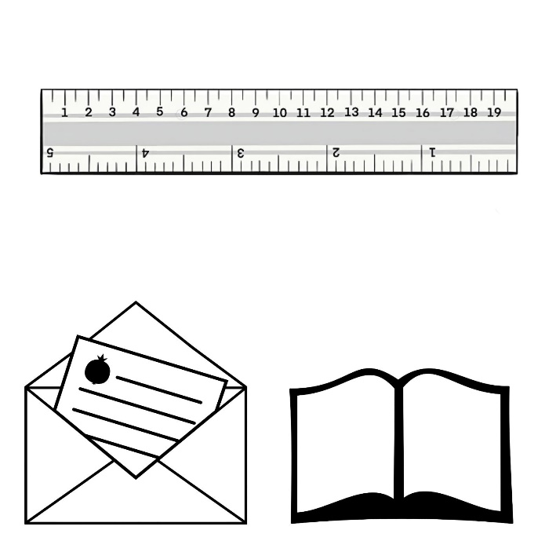​**7) Write the lengths of the following.**

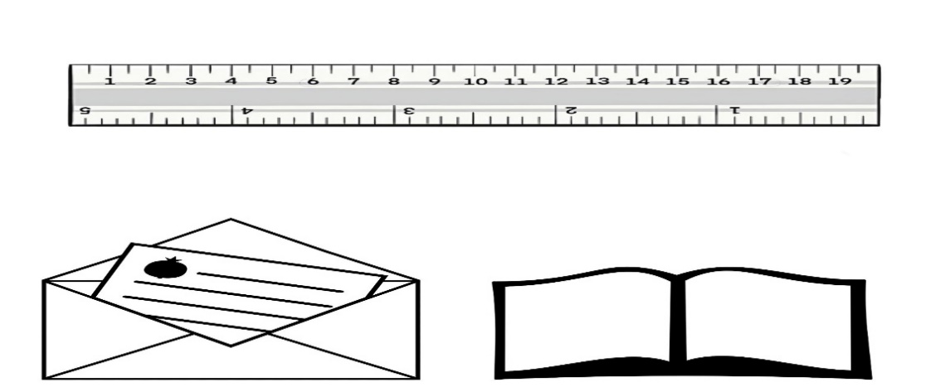

CM

CM





**8) Write their Roman numerals.**

15= _______________ 10=_________________

9= ________________ 5=__________________

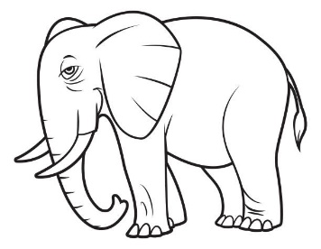**9) Write ‘G’ for greater and ‘S’ for smaller.**

b)

a)

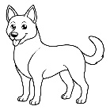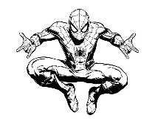

**10) Write ‘M’ for more capacity and ‘L’ for less capacity**.



**11) What comes between?**

135 137 840 842

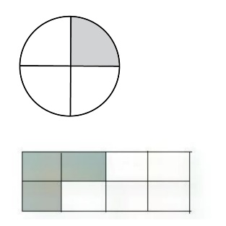**12) Write the fraction of the given shaded parts**.



**13) Match the correct fraction.**

$4/8$

$1$

$1/2$

$1/4$

**Group ‘C’[4×4=16]**

​**14) Subtract the following vertically.**

1 7 2

1 3 0

8 6 4

4 4 6

5 6 7

2 9 5

0 3 2

2 0 5

​**15) Solve the following word problems.**

1. Dolma has 124 cows and 573 goats. How many cattle does she have altogether?

|  |  |  |
| --- | --- | --- |
|  |  |  |
|  |  |  |
|  |  |  |

She has __________ cattle in all.

1. I have 393 rupees and Anpan has 408 rupees. How much do we have in all?

|  |  |  |
| --- | --- | --- |
|  |  |  |
|  |  |  |
|  |  |  |

We have ____________rupees in all.

**16) Add the following.**

CM MM 5

CM MM 5

75 4

13 5

10 4

85 5

|  |  |
| --- | --- |
| **CUBE** | **CYLINDER** |
|  |  |

**17) Draw the following**.

**The End**